**Binary Tree Types**

1. Full (Strict) Binary Tree

Tree with inner nodes having 2 nodes and leaf nodes having zero nodes.

Example :-

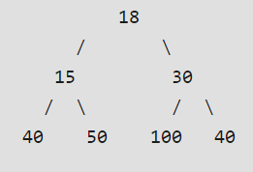 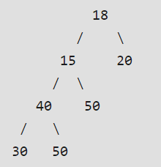 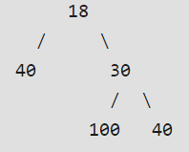

1. Complete Binary Tree

A Binary Tree is complete Binary Tree if all levels are completely filled except possibly the last level and the last level has all keys as left as possible.

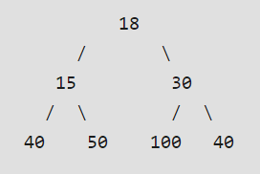

**1 Complete Binary Tree and a Full Binary Tree**

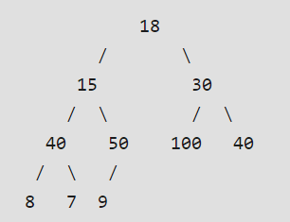

**2 Only Complete Binary Tree and Not Full Binary Tree**

1. Perfect Binary Tree

A Binary Tree where all internal nodes have 2 children and all leaf nodes are at same level. A Perfect Binary Tree is also a Complete Binary Tree and a Full Binary Tree.

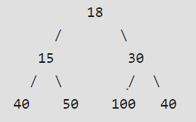

1. Balanced Binary Tree

Height of such a tree is O( log N) where N is the number of Nodes.

Constraint : Mod | Left Subtree Height – Right Subtree height | <=1

1. Degenerate/Pathological Binary Tree

Every Internal node has only one child. Performance wise it is same as LinkedList.

